24 Durrington Road | ELIZABETH, SA 5112p 8252 3044 | e: admin@playfordcollege.sa.edu.au | www.playfordcollege.sa.edu.au
Playford College
Annual Report 2018

Wisdom through Faith & Knowledge

Principal’s Report

Playford College is a success story!
Commencing in 2017 with 70 children, the College has grown into a successful Reception to Year 8 school of nearly 241 students and 32 staff, at Census Day in August 2018. Enrolment trends suggest we may be close to 300 hundred students by commencement of school in 2019.
Students have come from over 40 schools and the committed and dedicated staff are building a new school culture based on the Playford Way which comprises 'Looking after yourself’, 'Looking after others' and 'Looking after this place'.
As we look to 2019, we envisage a newly established Middle School for students in Years 6 to 9 who will experience specialist teachers each lesson, individual laptops, electives and the opportunity to flourish.
In 2019 the College will continue to provide MiniLit and MacqLit programmes for students who need further teaching and support with acquiring English and Reading skills. With 99% of our students coming from non-English speaking backgrounds, the College has committed significant funds to staff these programmes and already the success of students is being celebrated.

Reading Eggs and Mathletics will continue during 2019 and we expect for these programs to continue to benefit our students’ Literacy and Numeracy skills.

During 2018 the College successfully applied to the Registration Board to progress to Year 9 and was audited for its teaching and learning programmes and all other aspects of school life. Although a rigorous process, the College was acclaimed for its progress in such a short time. Many partnerships/relationships with the wider community will develop in the latter half of the year including with the Lions Club of Elizabeth Playford, St Peter's Lutheran Church, the Playford Council Mobile Library Service, the Northern Adelaide Senior College, the Elizabeth TAFE and Flinders University. The College is hopeful that these relationships will further enrich the lives of our students during 2019.

The College was grateful to the South Australian Government's Capital Works grant which will establish a modern, stable and improved computing system during early 2019. A more reliable Internet and server-based infrastructure will improve student learning and staff satisfaction immeasurably.
The buildings and learning spaces have been renovated to accommodate the fast growth in the student population. During the January 2018 holidays 4 classroom spaces were created ready for the large growth and learning spaces will need to continue to be established. The College is pleased with its new Master Plan as we look to the future and hopeful of gaining Federal Government grants to assist with building projects during 2019 and the years beyond.

The College motto of "Wisdom through Faith and Knowledge" is becoming a reality in this faith based Islamic school in Elizabeth.

Chris Riemann

Principal
Dip T, BEd, GradDipEdAdmin, MEdM, MACEL

Value Added

ICT – Laptops, iPads, Computer Suite
In 2018, just our 2nd year of operation, all of our high school students were provided with a 1:1 ratio of laptops. This enabled them to fully utilize Google Classroom and allowed them to further enhance their learning through the use of ICT. Our primary students had a ratio of one iPad for every four students. This allowed primary students access to ICT on a daily basis. Our Computer Suite was completed in 2018, enabling each student to work with a proper keyboard and mouse. Upper primary students used Typing Club

Spiritual Dimension
The Illumination team provides spiritual leadership beyond teaching the Illumination lessons as part of the curriculum.

Prayer
At Playford College we hold daily corporate prayer after lunch. Prayer leadership roles are given to senior students, guided by our Sheikh and the rest of the Illumination team.

Pastoral Care
Pastoral care is an after-school program which is hosted by the Illumination team. During the program, students who are enrolled are given an opportunity to do their work with extra support as well as engage in discussions revolving around Islamic ideas in the contemporary world. We also share a meal together and conclude the session with entertainment. The importance of such a program is to enrich the learning of the student and to build a stronger sense of family and belonging to our Playford community.

Celebration of Religion events
We celebrated the births of all Imams during our lessons as we discussed their lives and their ever-lasting legacy. We had specific programs for the birth of Imam Ali, Imam Mahdi and Lady Fatima. We commemorated the Martydom of all Imams who were martyred as well, however we had special programs for Muharram and Arbaeen.

Camps and Excursions

Year Level Camps
Playford College puts a strong emphasis on personal and social development. Each year, students embark on a camp to provide many opportunities for teamwork, leadership, independence and life experience. In 2018, students took part in the following camps:
Year level | Camp | Number of nights
Reception | Stay back | 0
Year 1 | Zoo Snooze | 1
Year 2 | Playford College Camp | 1
Year 3 | Adelaide Shores Camp | 1
Year 4 | Narnu Farm Camp | 2
Year 5 | Woodhouse Activity Centre Camp | 2
Year 6 | Glenhaven Park Camp | 2
Year 7/8 | Canberra Tour | 4

Hajj Camp
In addition to the year level camps, each year Playford College holds a Hajj Camp for its students in Year 3 and up. The R-2 students also participated in special Hajj activities in the same week.

Every year millions of Muslims from around the world travel to the holy city of Mecca as part of Hajj, being the Muslim pilgrimage. At Playford college, we learn and partake in the Hajj by having a Hajj Camp. At Hajj Camp students are introduced into the philosophy of Hajj as well as partake in some of the rituals at a smaller scale. The camp is important to our school as we believe that some of the philosophes of Hajj, such as patience and resilience, are crucial to a student’s learning. Overall, we had a great camp and are looking forward to having future Hajj camps over the coming years.

Excursions/Incursions
 | Excursion / Incursion
Junior Primary | Playford Library, Humbug Scrub, New Town Park, Adelaide Fire Station, Adelaide Oval, Henny Penny Hatchlings, Alphabet Day, Urrbrae Farm, SAPOL Incursion
Middle Primary | Indigenous Art Incursion, Botanic Gardens,
Upper Primary | Adelaide Gaol, Parliament House, SA Museum, Flip Out Team Building, SA Maritime Museum
High School | Latitude Team Building, Hallett Cove Field Study, Raffle Organisation Day

School Events
Playford College hosted and took part in many events in 2018. Some of the highlights of the year included:

- End of School Concert
- Swimming Lessons
- Year 6 Graduation Dinner
- Harmony Day
- Book Week
- Science Week
- Book Fair
- Jump Rope for Heart
- Growing Up Smiling (GUS) free dental service for students
- SAPSASA Soccer Year 5, & 7 Boys and Girls
- SANFL Clinic
- IPSHA Poetry Recital Competition
- MELC My Kitchen Project
- Sports Day
- Visits from representatives of every level of government:
  - Local Government
    - The Mayor of the City of Playford: Glenn Docherty
  - State Government
    - Member of the SA House of Assembly for Elizabeth: Lee Odenwalder
  - Federal Government
    - Member of the Australian Parliament for Spence: Nick Champion
- Author visit: Phil Cummings
- Premiers Reading Challenge Reception 2018
- Participation in the Premiers Reading Challenge
- Remembrance Day Ceremony
- Ramadan
- Iftar Dinner
- Unity Day

Community Links

Playford College Parents Committee (PCPC)
In 2018 the PCPC developed into a much stronger community group. They organised an Iftar dinner that catered for more than 300 people in the school community. The dinner was a resounding success and was a fantastic way to build community with the friends and family of Playford College. The PCPC also provided essential assistance with the Mother’s Day Stall, Father’s Day Stall and Hajj Camp.

Social Justice Club
Our Social Justice club organised a can drive to collect donations for the Anglicare Mission in Elizabeth.

Other partnerships
In 2018, Playford College deepened its connections to the local community with partnerships that have enriched the lives of our students. The College has already shown great benefits from donations, resources and a wealth of volunteers from the Lions Club of Elizabeth and St Peter's Lutheran Church.

The Playford Council Mobile Library Service started visiting the College fortnightly in 2018, allowing students to conveniently access their massive collection of books.

In 2018 we have been developing growing relationships with The Northern Adelaide Senior College, The Elizabeth TAFE and Flinders University to assist each other with the teaching and learning of all of our students. This will lead to massive benefits for the students of Playford College for years to come.

NAPLAN

Mean Scale Scores 2018
 | Reading | Writing | Spelling | Grammar | Numeracy
Year 3 | 354 | 340 | 419 | 398 | 371
Year 5 | 455 | 418 | 491 | 465 | 435
Year 7 | 526 | 514 | 539 | 556 | 538

Mean Scale Scores as Proficiency Bands 2018
 | Reading | Writing | Spelling | Grammar | Numeracy
Year 3 | 3 | 3 | 4 | 4 | 3
Year 5 | 5 | 4 | 6 | 5 | 5
Year 7 | 6 | 6 | 7 | 7 | 7

More details about NAPLAN data can be found at the My School website at: https://www.myschool.edu.au/school/52468/naplan

Students 2018

Enrolments
 | Male | Female | Total
Reception | 14 | 29 | 43
Year 1 | 14 | 12 | 26
Year 2 | 14 | 12 | 26
Year 3 | 12 | 13 | 25
Year 4 | 18 | 17 | 35
Year 5 | 17 | 13 | 30
Year 6 | 17 | 16 | 33
Primary Total | 106 | 112 | 218
Year 7 | 5 | 5 | 10
Year 8 | 7 | 6 | 13
Secondary Total | 12 | 11 | 23
Whole School | 118 | 123 | 241

Student Attendance
Year level | Term 1 | Term 2 | Term 3 | Term 4 | Total
Reception | 84.09 % | 87.70 % | 85.24 % | 81.08 % | 84.53%
Y1 | 85.40 % | 87.85 % | 85.81 % | 82.03 % | 85.27%
Y2 | 93.06 % | 93.25 % | 93.83 % | 86.40 % | 91.64%
Y3 | 94.99 % | 94.58 % | 93.58 % | 92.19 % | 93.84%
Y4 | 92.71 % | 89.59 % | 89.52 % | 83.62 % | 88.86%
Y5 | 94.66 % | 94.30 % | 92.05 % | 91.60 % | 93.15%
Y6 | 95.77 % | 95.25 % | 90.47 % | 85.41 % | 91.73%
Y7 | 97.85 % | 93.22 % | 92.92 % | 90.84 % | 93.71%
Y8 | 96.68 % | 95.97 % | 87.64 % | 82.74 % | 90.76%
Whole school | 92.80% | 92.41% | 90.12% | 86.21% | 90.39%

Satisfaction
The rapid growth of the school is a clear indication of the community perception. In its first year, many members of the community were hesitant to join a start-up school with no track record. In 2018, with a clearly pleasing reputation, many more families were keen to join the school. The following surveys were conducted with parents of the community, students and staff.

Parent Satisfaction Survey 2018
The range of learning areas offered at this school is excellent.  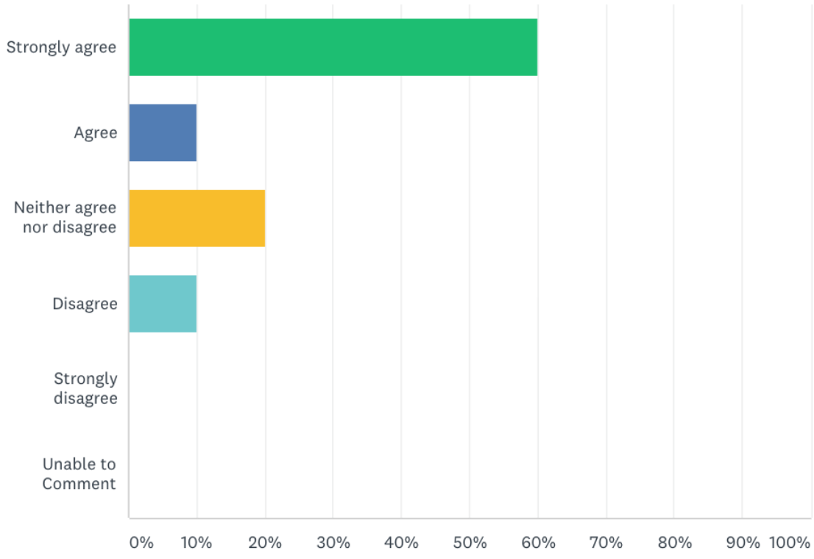 | The quality of teaching at this school is excellent.  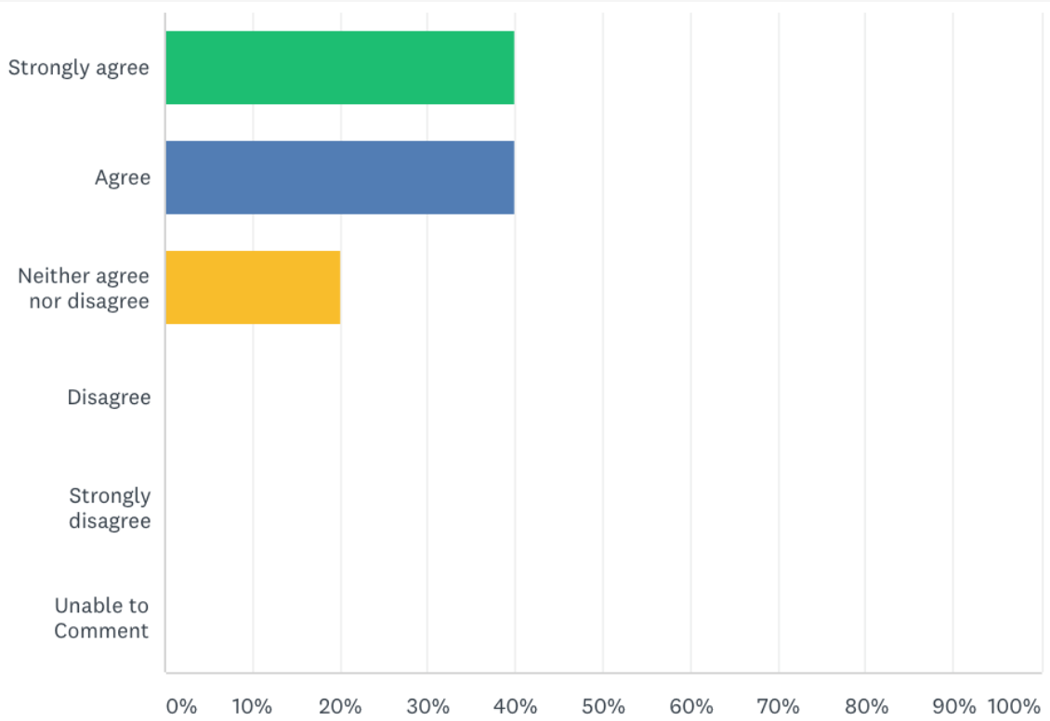
Teachers at this school are keen to help students of all abilities. 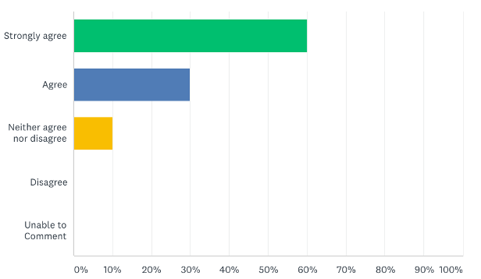 | Teachers provide excellent help and support for students when is needed. 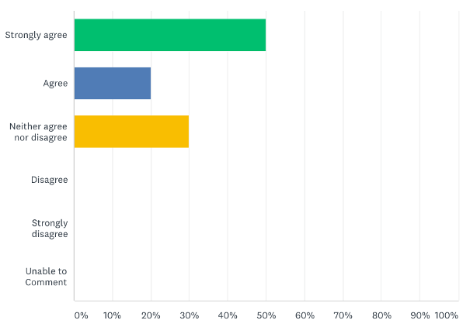
The school is a safe place in which to learn.  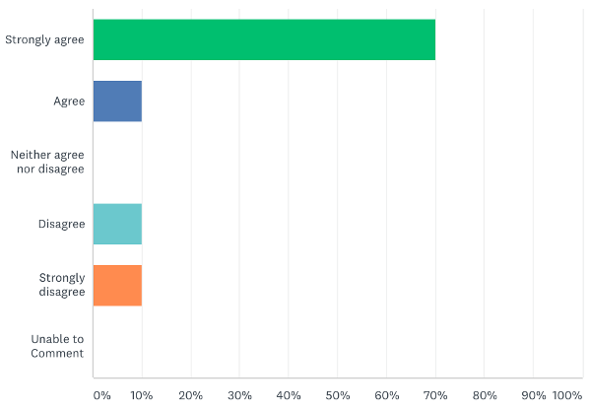 | The discipline at this school follows established and well-known procedures. 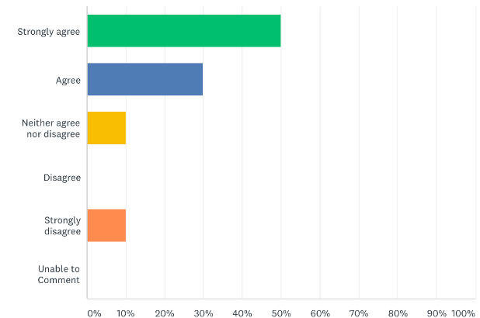
The school uses a broad range of communication types to keep parents informed.  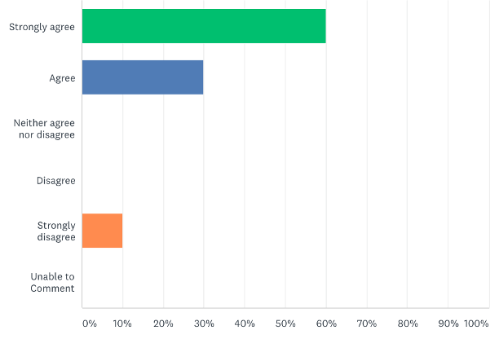 | I am happy to recommend the school to other parents.  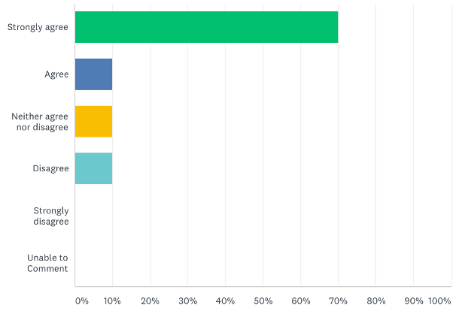

Staff Satisfaction Survey 2018
The Principal/Senior Management team has a clearly articulated vision for the school. | Staff take prompt action when problems occur.
This school is a safe place for students to learn. | The school clearly communicates its expectations for student behaviour.
There is open communication between staff and parents at this school. | Students are motivated to learn at this school.
Administrators, teacher and other staff treat each other with respect. | The school offers appropriate professionals development opportunities for staff.

Middle School Student Satisfaction Survey 2018
I am encouraged to try my best at my school. | I understand my school's expectations for student behaviour.
I am treated fairly at this school. | My school provides excellent learning resources.
I am proud to a part of this school. | My teachers regularly correct my work.
My school is a safe place in which to learn. | I understand what I have been taught.

FINANCIAL

The abridged Financial Statements for Playford College are presented on the next two pages.
The College accounts were duly audited and certified that the financial report presents fairly the results of its operations for the year then ended.

PLAYFORD COLLEGE LIMITED

ABRIDGED FINANCIAL STATEMENTS FOR 2018

STATEMENT OF INCOME AND EXPENDITURE FOR THE YEAR ENDED 31 DECEMBER 2018
2018 2017
$ $
INCOME
Tuition Fee (Net) 203,934 80,910
Commonwealth Government Grants 2,601,037 1,039,158
State Government Grants 703,169 258,573
Other Grants 25,039 0
Other Income 122,440 47,013
Other Donations & Fundraising 16,387 10,586
TOTAL RECURRENT INCOME $3,672,006 $1,436,240

EXPENSES
Employee Expenses 2,417,039 891,233
Tuition Materials and Expenses 157,554 49,988
Property Expenses 166,810 144,725
Administration Expenses 256,325 53,258
Interest 0 18
Depreciation 26,676 4,856
TOTAL RECURRENT EXPENSES $3,024,404 $1,144,078

SURPLUS FROM RECURRENT INCOME AND EXPENSES $647,602 $292,162

NON OPERATING INCOME
Building Fund Transfer 0 38,093
Capital Fees & Levies 23,756 21,100
Commonwealth Capital Grants 4,850 0
State Government Capital Grants 57,500 0
TOTAL NON OPERATING INCOME 86,106 59,193

NON OPERATING EXPENSES
Depreciation, Buildings 1,763 0
Loss on sale of fixed asset 0 0
TOTAL NON OPERATING EXPENSES 1,763 0

NET SURPLUS FOR THE YEAR 731,945 351,355

BALANCE SHEET AS AT 31 DECEMBER 2018

2018 2017
ASSETS $ $
CURRENT ASSETS
Cash and Cash Equivalents 1,160,382 349,929
Trade and Other Receivables 38,100 21,473
Other Current Assets 0 0

TOTAL CURRENT ASSETS 1,198,482 371,402

NON CURRENT ASSETS
Property, Plant & Equipment 235,954 123,876

TOTAL NON CURRENT ASSETS 235,954 123,876

TOTAL ASSETS 1,434,436 495,278

CURRENT LIABILITIES
Trade and Other Payables 280,709 136,879
Other Financial Liabilities 10,000 111,920
Short Term Provisions 95,866 0

TOTAL CURRENT LIABILITIES 386,575 248,799

NON CURRENT LIABILITIES
Other Financial Liabilities 6,324 0
Long Term Provisions 36,072 0

TOTAL NON CURRENT LIABILITIES 42,396 0

TOTAL LIABILITIES 428,971 248,799

NET ASSETS $1,005,465 $246,479

ACCUMULATED FUNDS
Accumulated Surplus (Deficit) 1,005,465 246,479
Reserves 0 0

TOTAL ACCUMULATED FUNDS $1,005,465 $246,479

Workforce
The incredible growth of Playford College in 2018 is clearly reflected in the workforce. At the end of 2017, the College workforce consisted of 6 teaching staff and 2 non-teaching staff. The College more than tripled its workforce the following year.

2018 Staffing

 | Headcount | FTE | Absenteeism
Teaching staff | 19 | 17.2 | 2.8%
Non-Teaching Staff | 7 | 4.7 | 1.2%
Total | 26 | 21.9 | 2.4%
Playford College employed no indigenous staff in 2018

Teacher Qualifications
Teacher | Qualifications
Lyn D'Sylva Peck
Erin Gracey
Bottol Jaffri
Julia Mayer
Donna Nguyen
Lenet Asudyia
Sharon Bristow
Hannah Fennell
Emily Harris
Kevin Hung
Kate Jones
Frances Leckstrom
Lyle Paterson
Nicole Schiller
Racha Makki
Naveen Budair
Shakillah Zaffar
Chris Riemann
Sheikh Idress UI Hassan
Abrahim Al-Zubeidi

Professional Development
Some of the professional development opportunities our staff engaged in during 2018:
- First Aid Training, including CPR, Asthma and Anaphylaxis training for all staff
- Bill Hansberry from Hansberry Educational Consulting
- School visit: Hills Christian Community School
- Weeklong PD at AISSA on School Culture, Conceptual Planning, Backwards Design, AITSL APST, ACARA Achievement Standards
- AISSA Induction Program for Early Career Teachers
- Program training sessions:
  - Reading Eggs
  - Mathletics
  - Jolly Phonics
  - Jolly Grammar
- Macqlit Intervention Program
- Reporting on Abuse and Neglect Training
- Carclew and Arts Live

Playford College School Improvement Plan 2017-2021

Preface
As a new school Playford College will be constantly challenged at every level of endeavour, as it seeks to establish itself. At the same time, understanding and then responding to those challenges will allow the new entity to be geared for success from the very outset.

Playford College started in February 2017 in Elizabeth, on the site of the redundant DECD Elizabeth Special School, with 78 students and had enrolments of 106 by year’s end. These students were divided into 5 classes across Reception to year 7. The school is located in a low socio-economic demographic and at its core is an Islamic school, but with a twist. The school has a clear intent, with its focus on the Australian Curriculum, to make itself available to the wider community. It acknowledges that the overlay of Islamic studies may present as an obstacle to the broader community of Elizabeth, but a guiding ambition of growing into a ‘lighthouse’ school, known for its care, high levels of expectation and respectful community remains as a cornerstone of the school.

Demand for places at Playford College is high, and the school expects to operate in 2018 with over 200 students. The school will move into junior secondary from 2018, adding Year 8 and following up with Year 9 in 2019.

The school has a clear focus on delivering a program of Islamic studies, known as the Illumination Program. While the school is open to all, Muslim people from a Shia background will be familiar with the teachings of Playford College.

All students are valued as unique individuals and at Playford College they are challenged to develop into the best possible versions of themselves. As over 95% of our students come from a non-English speaking background there is a strong focus on literacy. The curriculum is based around this, but also continues to build on numeracy and provide rich experiences in all other curriculum areas. While it will be a challenge, Playford College will look to embark upon and accelerate the uptake of STEM.

Playford College has already extended it offering from an originally mooted Reception to Year 6 school to Reception to Year 7, followed by Year 8 in 2018 and Year 9 in 2019. It is working towards offering a seamless Reception to Year 12 experience by 2021.

The School Improvement Plan maps how we articulate our motto: Wisdom through Faith and Knowledge and is underpinned by the school’s mantra of respect: respect for God, respect for self, respect for others and respect for property, and the school’s learning principles.

Reform Areas
Playford College’s School Improvement Plan seeks to identify and implement strategies and innovative actions that simultaneously fulfil its vision and respond to the national school improvement agenda (NSIA) and the five reform areas, namely:
- Quality teaching
- Quality learning
- Empowered school leadership
- Meeting student needs
- Transparency and accountability

Self-Assessment
As a brand-new entity, the school is blessed by having a blank canvas upon which to create. Even though this blank canvas allows us to apply whatever colour scheme to whatever landscape we like, stakeholders need to constantly ask themselves if the image being created remains clear and understood by its audience. What tools will we use to audit our performance? What activities will be undertaken to gather the required data? How will staff and governance analyse the quality of Playford college? How will we know that we are continuing to improve what is Playford College?

2017-2021 Focus Elements

While the transition from the plan to have a school to the execution of that plan has happened, every subsequent action in the school is a first-time experience. After the first term, the first semester, the first year, there will be some time to reflect and then prepare and respond to the next period of time. Being devoid of a history and resource poor our self-assessment and review processes will be lightweight in the first instance. It is however, possible to identify a number of areas of priority for Playford college, based on past experience and the observations of staff, students and parents and the school board.

1: Excellence in Learning
Playford College has from the outset, set itself the vision of being a ‘lighthouse school’. To successfully pursue this vision, Playford College values excellence and creativity in teaching and learning – this involves all staff and all students. As the school establishes itself, at its core will be a culture that simultaneously challengers and supports its members to commit to lifelong learning.

Excellence in teaching and learning is focused on improving student outcomes which include spiritual, academic, physical, social, emotional dimensions. All learners should have access to quality learning experiences that ensure their abilities are developed to the point where they can value-add and enrich the environment within which they live and operate. High expectations are established through reflective practice, collaborative planning, monitoring, providing feedback and reporting on the effectiveness of learning. The learning environment promotes active engagement, risk taking, motivation and a strong learner voice.

2: Ongoing Improvement and Innovation
Improvement at Playford College will be guided by our motto of ‘Wisdom through Faith and Knowledge’, woven into the mantra of respect. These values provide a perfect segue to the pursuit of excellence, as we seek to build into our culture cornerstones of reflection, collaboration, innovation and creativity. Evidence is gathered to develop and implement improvement plans and policies for the continued development of teaching and learning, the school and its facilities. Ongoing professional development encourages all members of the community to achieve high standards and develop their service and leadership capacity.

3: Strengthening the School’s Identity
Playford College was established to provide an alternative within the Islamic offering of schools in South Australia. Its spiritual program seeks to provide a well-lit path for students to follow, hopefully for the rest of their lives. It provides Islamic education according to the Ja’fari School of Thought (Ithna-Asheri) which emphasizes adherence to the Holy Qur’an and the Ahal-al- Bayt of the Holy Prophet (saww), and to increase awareness of its divine and deeply rooted principles.

The spiritual program, known as the Illumination Program, is an integral means by which the College can assist parents in the education of their children in a total sense. The mantra of 'respect' is echoed and practised daily. In addition to striving to be the best we can be academically, we also strive to be the best we can be personally. This affects how we relate to others - at school, at home and in the wider community. Playford College is a stable and supportive environment for students to interact and socialise in. By providing support in daily life activities and their academic development the College also encourages and models appropriate moral behaviour. Through these teachings, the students’ self-confidence and character will be highly valued and a credit to the Islamic community in Australia.

This will appeal to a certain cross section of the Islamic community, placing upon Playford College the challenge to ensure it continues to develop in a way that acknowledges this focus while striving to broaden its appeal to a broader base, in keeping with the vision of becoming a lighthouse school.

4: Building Community
At Playford College we value the richness and diversity of our community. It gives the school the opportunity to develop and maintain positive and strategic partnerships with students and their families. The nature of our school also compels us to investigate and create positive and meaningful relationships with other schools, other educational institutions, other Shia communities and Islamic institutions and the broader non-Muslim community. Building community will afford our students opportunities to live out their faith in the active service of others.

The Playford College community has an opportunity to foster understanding of diverse cultures while learning about and understanding the multicultural and multi-faith nature of Australian society. Playford College promotes the understanding of, and respect for, Aboriginal and Torres Strait Islander people.

5: Leading Effective Organisation and Management
Playford College strives to articulate processes that enable staff to participate in the smooth and efficient running of the school. Data and knowledge management methods and technologies are applied to ensure efficiencies in every field of our endeavour (human, physical, technological and financial). Playford College seeks to manage these resources in ways that provide an effective, safe and caring, growth-oriented learning and working environment. Strategic planning ensures the ongoing improvement and sustainability of the school. Best practice is built upon effective collaboration between the governing body, staff, students and the families and wider community.

Unpacking the Focus Elements

Excellence in Learning

Goal 1
Embed the Australian Curriculum into the program of learning

Key actions
1: Develop the curriculum Reception to Year 6.
2: Develop Middle School Curriculum – Years 7-8-9

Goal 2
Develop a high level minimum standard of English proficiency

Key actions
1: Identify and then support students at greatest risk
2: Identify and introduce support structures and mechanisms to facilitate the raising of standards – Jolly Phonics; Daily 5; MaquLit; MiniLit
3: Apply standardised testing and use data to inform school of academic gains being made.

Goal 3
Develop a response to the global STEM agenda, making it relevant to Playford College

Key actions
1: Develop a digital strategic plan
2: Develop management strategies to support the schools digital agenda
3: Engage the community through social media
4: Master Plan - buildings and facilities coming online to reflect the national STEM School Education Strategy - 2016 -2026.

Ongoing Improvement and Innovation

Goal 1
Collect, analyse and apply relevant data to meet the needs of every child

Key actions
1: Professional learning for staff using the AISSA High Impact School Improvement Tool
2: Create and sustain a culture where data drives high impact learning opportunities for the benefit of all students

Goal 2
Enhance well-being through the promotion and implementation of Positive Education

Key Actions
1: Promote and build in a solution focused approach to the emotional needs of the students and their families.
2: Foster school wide understanding of positive psychology and the implementation of positive education strategies
3: Provision of ongoing professional learning for all stakeholder groups

Strengthening the School’s Identity

Goal 1
Strengthen the Playford College brand

Key actions
1: Continue to embed the school’s brand – Wisdom through Faith and Knowledge, respect,

Goal 2
Develop meaningful partnerships that help celebrate the school’s vision

Key actions
1: Collaborate with potentially connected community groups – make the connection

Building Community

Goal 1
Maintain and strengthen caring relationships

Key actions
1: Promote, develop and sustain a culture where all staff assume responsibility for caring for every student in the school
2: Plan, share and celebrate the school’s journey to lighthouse status with all stakeholder groups and the wider community
3: Collect and analyse satisfaction data and respond by allowing opportunities for the wider community to connect and grow together

Goal 2
Value, promote and support the cultural diversity within Playford College

Key actions
1: Engage with families to better understand and support learning needs and ensure inclusion
2: Build structures that provide non-English speaking families with opportunities to connect with the school
3: Share cross cultural stories across our community

Leading Effective Organisation and Management

Goal 1
Develop data knowledge and management methods in support of our innovation and improvement agenda

Key actions
1: Implement digital web-based student management platform
2: Implement web based financial platform

Goal 2
Ensure procedures and responsibilities are strategically and proactively developed to ensure the smooth and efficient operation of a new, agile, growing school

Key actions
1: Develop efficient and productive structures and work flows
2: Consult and clearly articulate all responsibilities and professional delegations

Goal 3
Develop variety of digital mechanisms to disseminate information and communicate with stakeholders

Key actions
1: Implement improvements in digital communication – parent portal; SchoolStream
2: Social media platforms – Facebook; Twitter

